Lab 1 - Set up your environment
Duration: 20 mins

Introduction
In this lab, you will learn how to activate the Dynamics 365 Contact Center trial license and explore the Copilot Service workspace. You will also navigate through the Copilot Service admin center to manage channels, view enabled communication options, and update user attributes such as skills, queues, and capacity profiles.

Task 1 - Enable Dynamics 365 Contact Center Trial
In this task, you will activate the Dynamics 365 Contact Center trial license using the Microsoft website and access the Copilot Service workspace.
- Open the Edge browser in the VM and paste the link !!https://www.microsoft.com/en-in/dynamics-365/free-trial!! for enabling the Dynamics 365 Contact Center Trial license.
- Scroll down and select Dynamics 365 Contact Center. Click on Try for free.
- 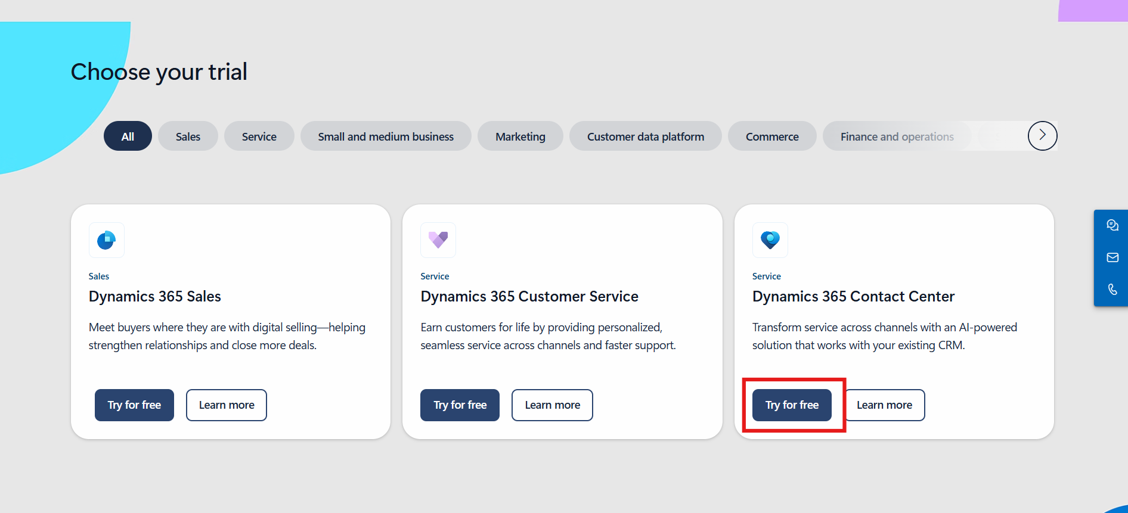
- Enter the user ID, select the agreement terms, and then select Start your free trial.
- 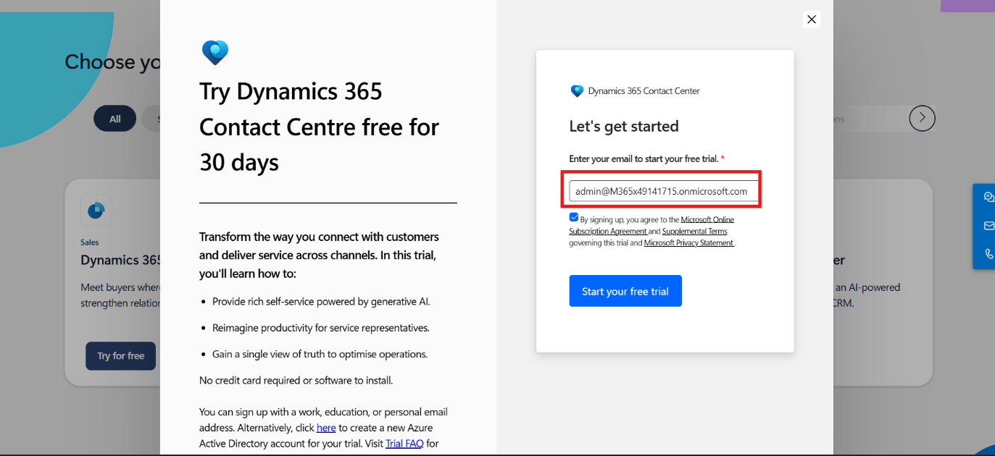
- Select Country/Region - United States and enter your phone number and submit.
- 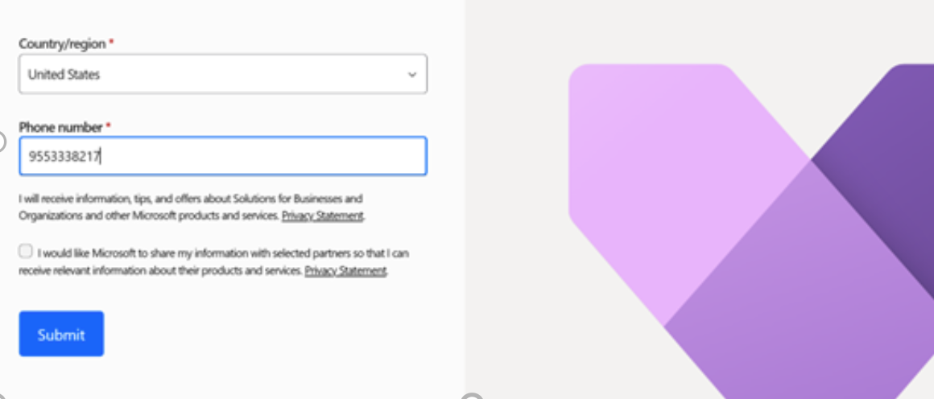
Note: If navigating to the direct sign-in page, enter the ID password in the field and then click on the Sign-in button.
- You will be navigated to the Copilot Service workspace.
- Note - If you are prompted with a pop-up for using a microphone, click Allow while visiting the site. If you are not prompted, you can proceed to the next step.
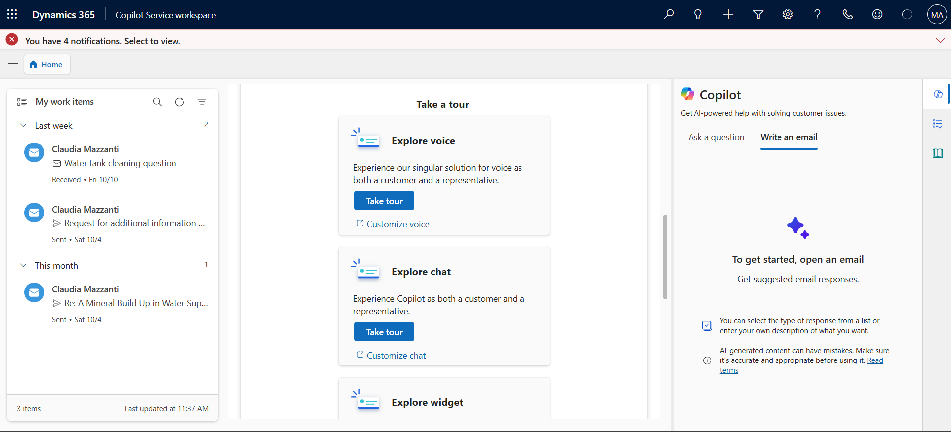

Task 2 - Explore Channels in Copilot Service Admin Center
In this task, you will navigate to the Copilot Service admin center to view and manage the available communication channels under Customer Support.
- Click on the App selector from the top.
- 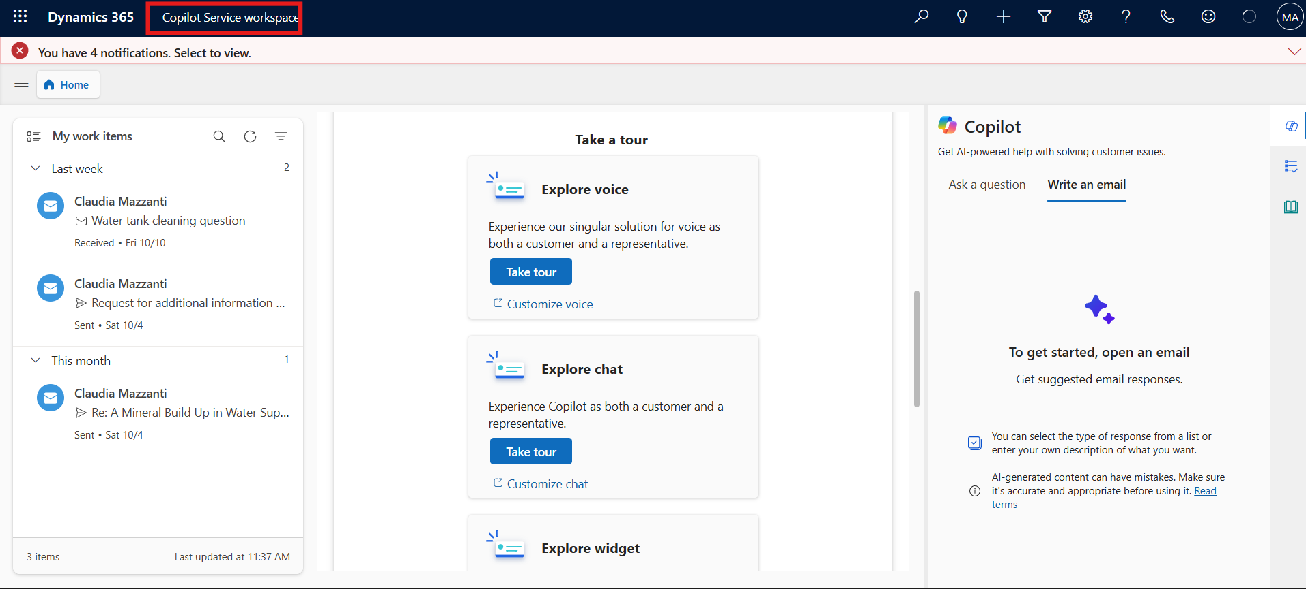
- Select Copilot Service admin center from the list of apps.
- 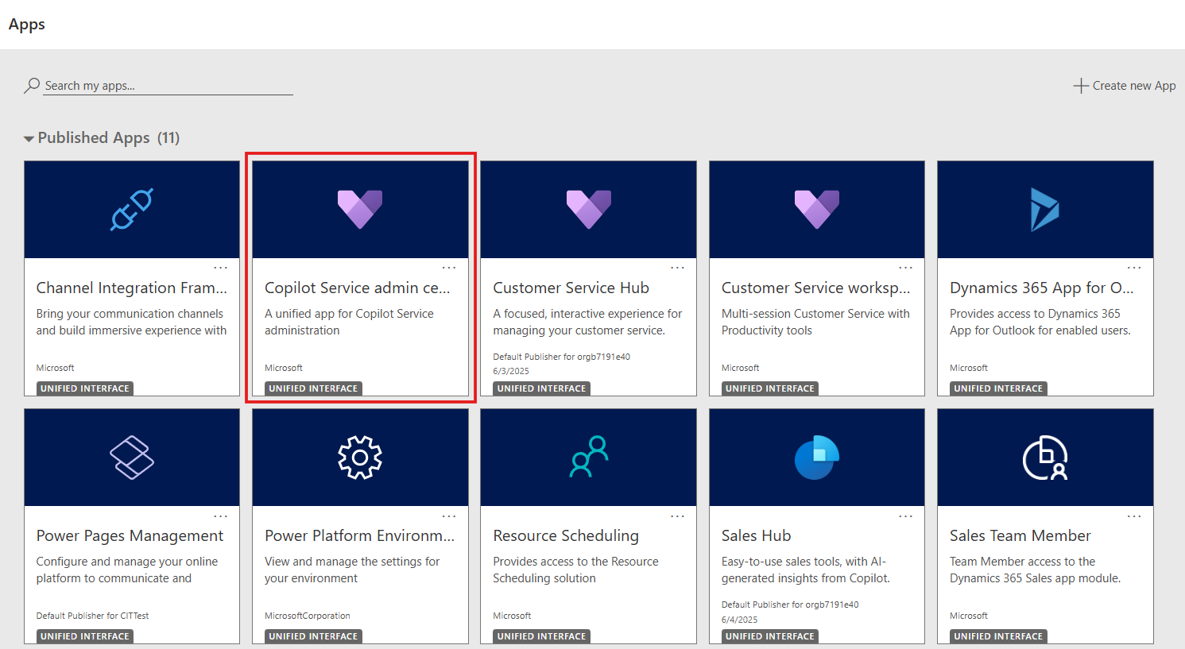

- Select Channels under Customer Support on the left navigation panel.
- 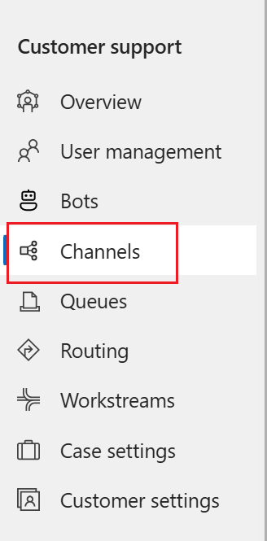
- Select Manage for Manage channels. The Manage Channels page appears.
- 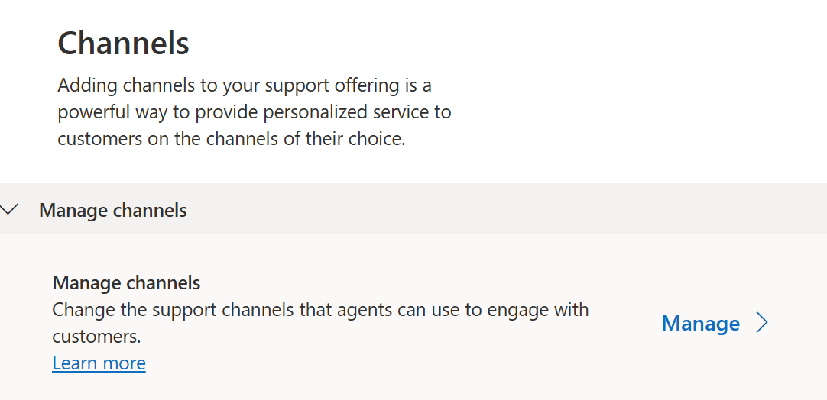
- You can view the channels that are enabled.
- 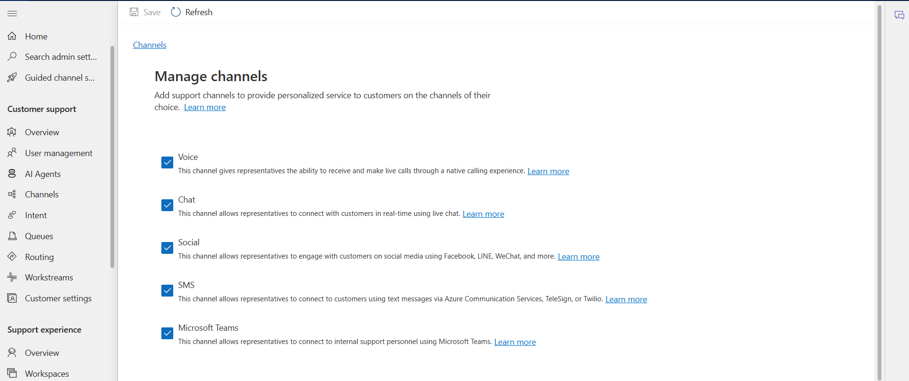

Task 3 – Manage Users and Update Attributes
In this task, you will access the User Management section in the Copilot Service admin center. You will update user skills, queues, and capacity profiles to configure user capabilities and workload distribution effectively.
- Select User management under Customer support in the site map.
- 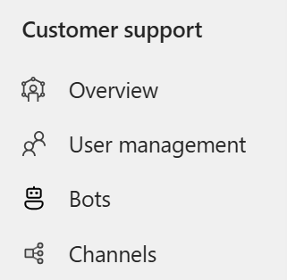
- On the page that appears, select Manage for Enhanced user management. The ‘Contact center users’ view displays the users that have been configured in the Power Platform admin center.
- 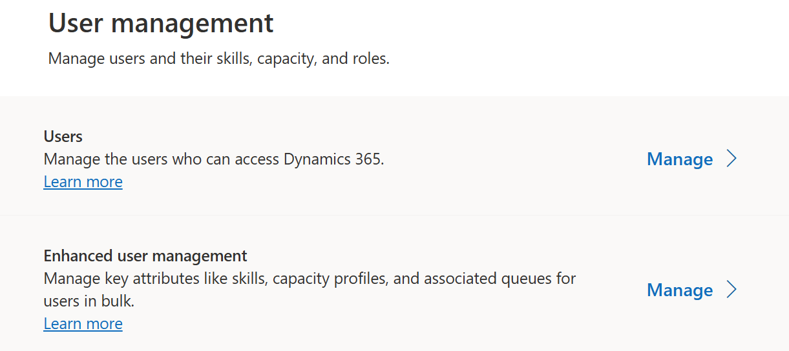
- Hover the pointer over the rows of your MOD Administrator users and select the check boxes.
- 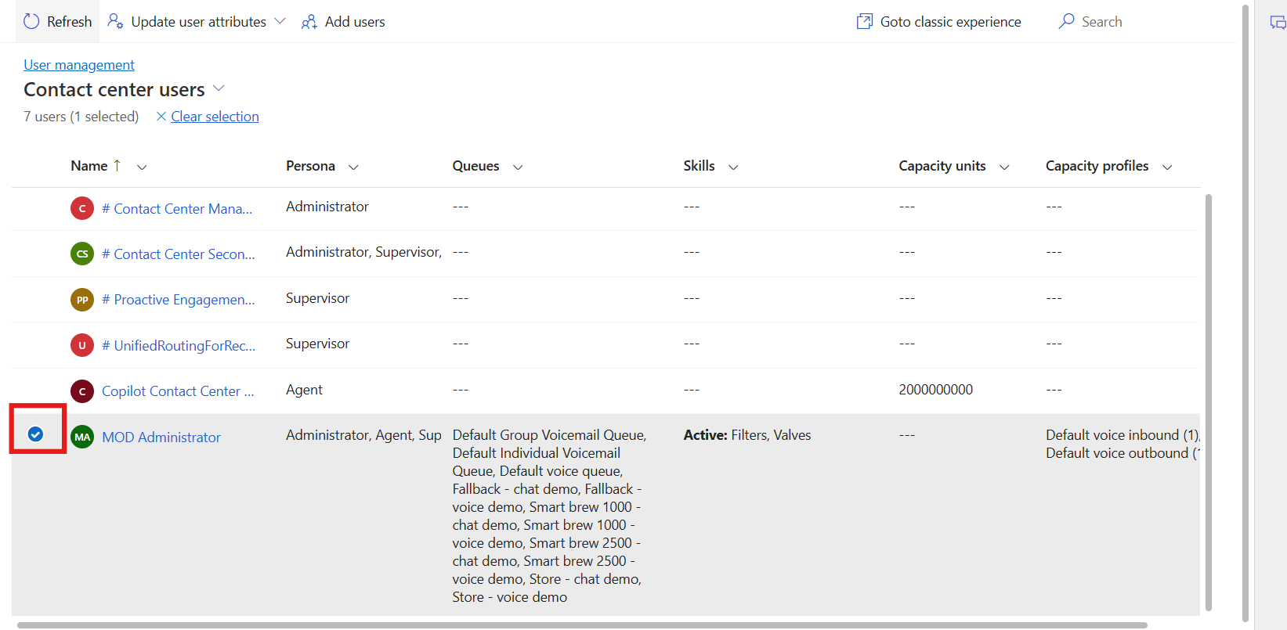
- To update user attributes, select Update user attributes, and you will see three options available. You can select one of the options based on your requirements.
- 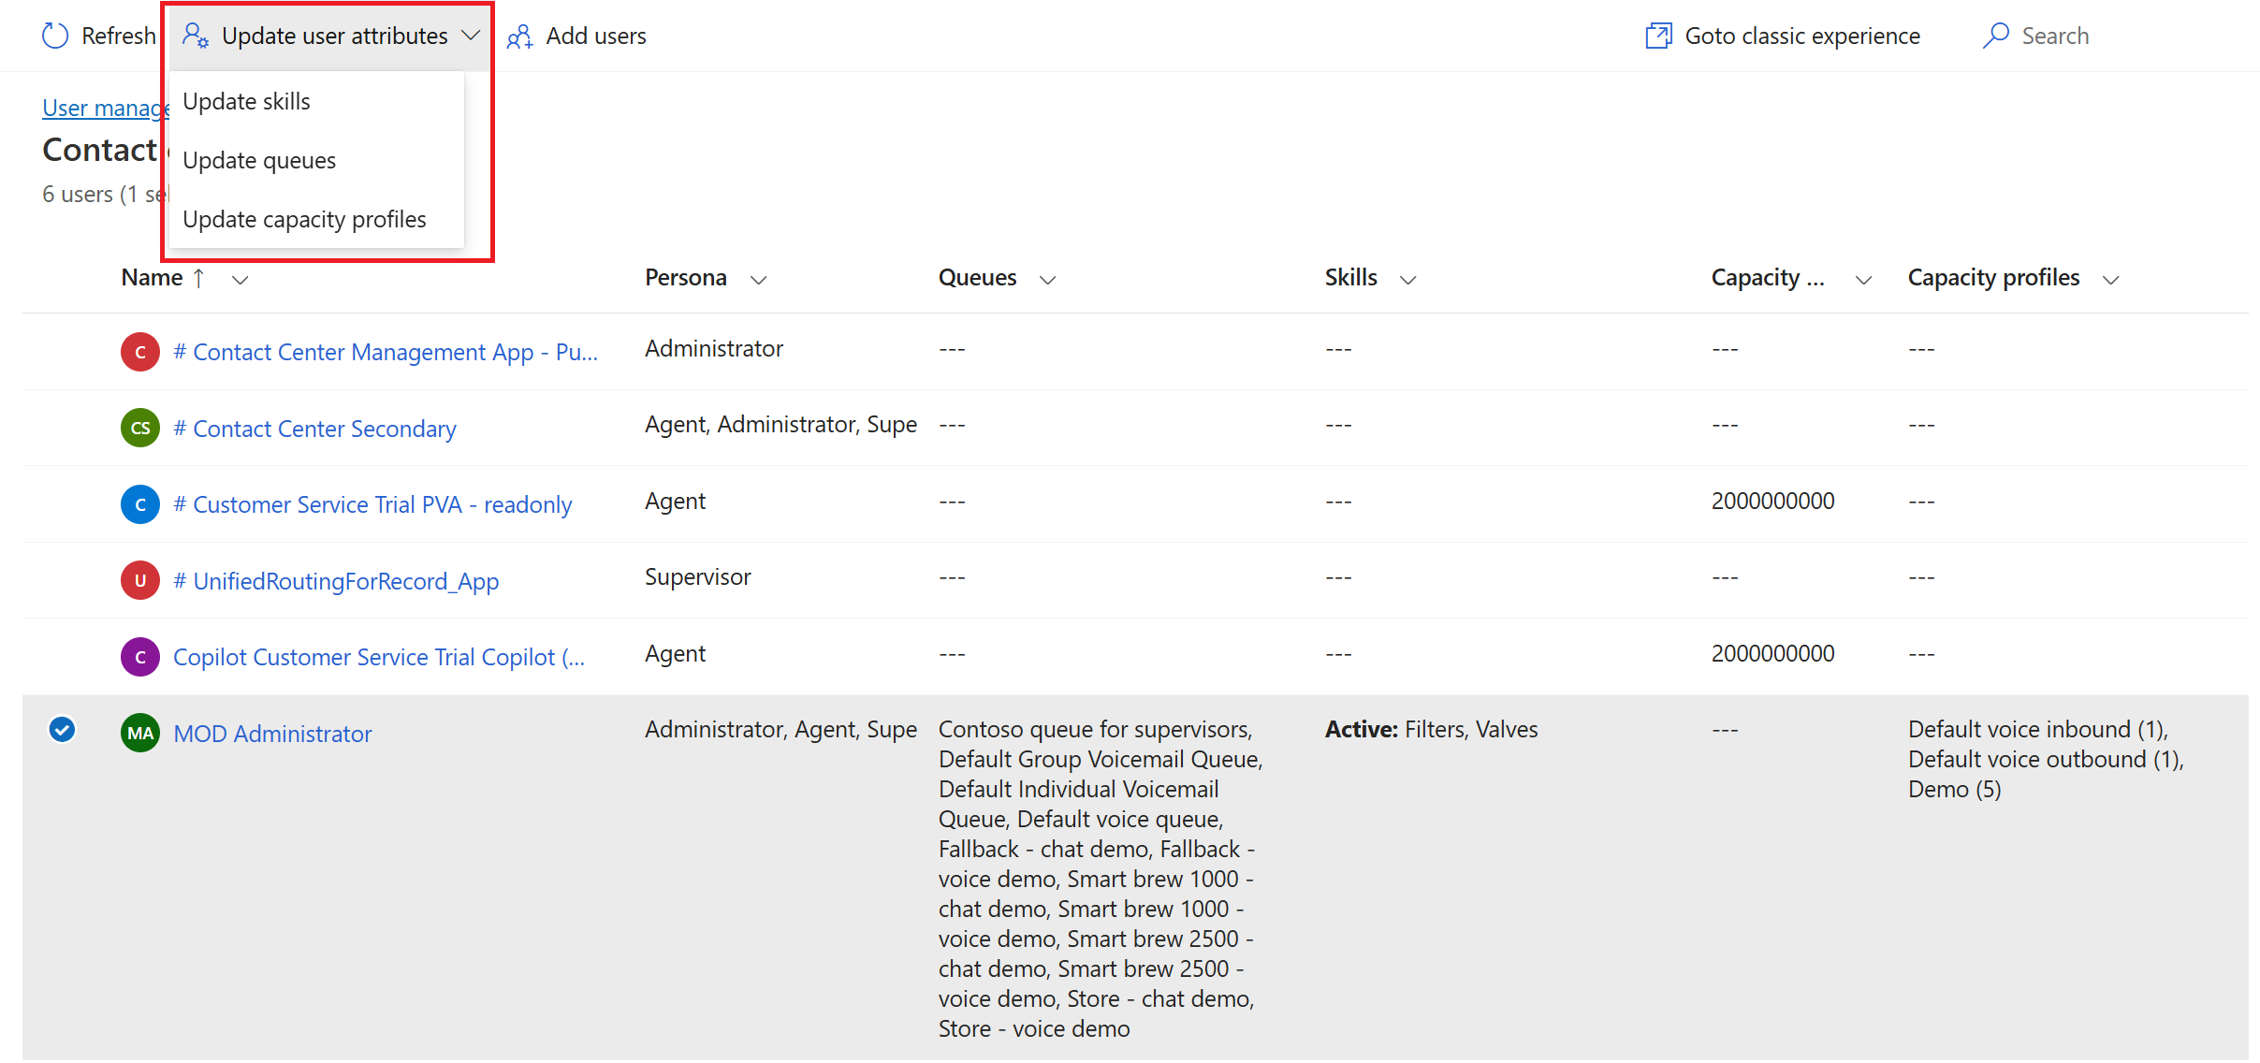
- Update skills: On the dialog box that appears, review and note the options available:
  - Add skills to users: In the Skills box, select the skills that you want to add, select proficiency, and then select Add to all. The selected skill and proficiency are added to the users list. To have a different proficiency in the skills, select one skill at a time.
  - Activate or deactivate: Select a skill in the Skills box and select the ellipses to select Activate for all or deactivate for all. Users with a deactivated skill will not be considered during assignment if the skill requirement of a work item matches the deactivated skill.
  - Remove skills: To remove a skill from the list of users, select the skill in the Skills box, and select Remove from all. Save your changes. The selected skills are removed for the users.
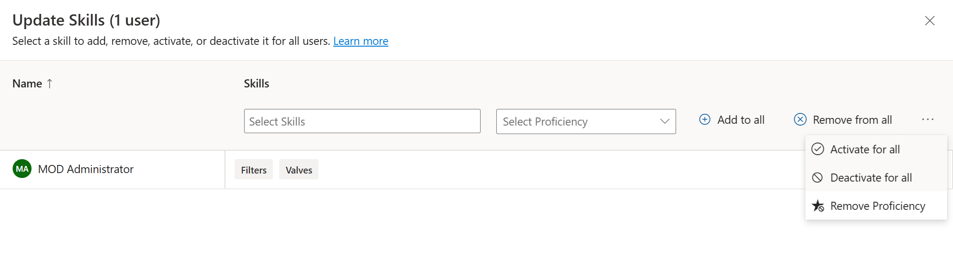
- Click on Close.
- Now select your Admin > Update user attributes > Update queues.
- Update queues: On the dialog box that appears, in the Queues box, review and note the options available.
- 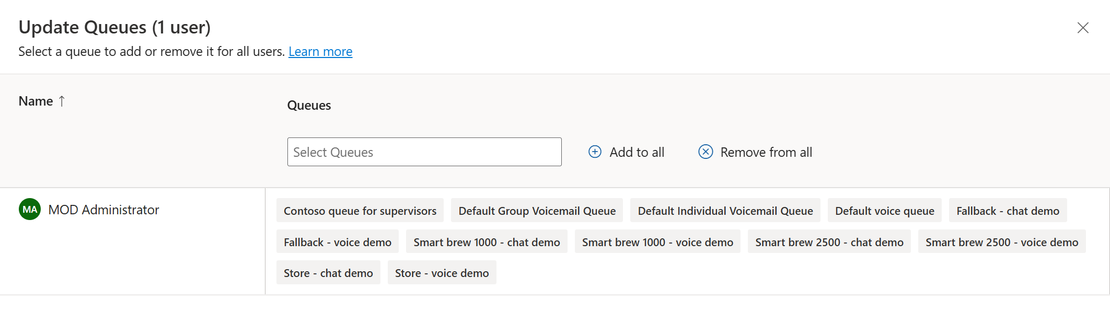
- Click on Close.
- Now perform step 7 again and select the Update capacity profile.
- On this dialog box, in the Capacity profiles box, select the profiles, review and note the options available.
- 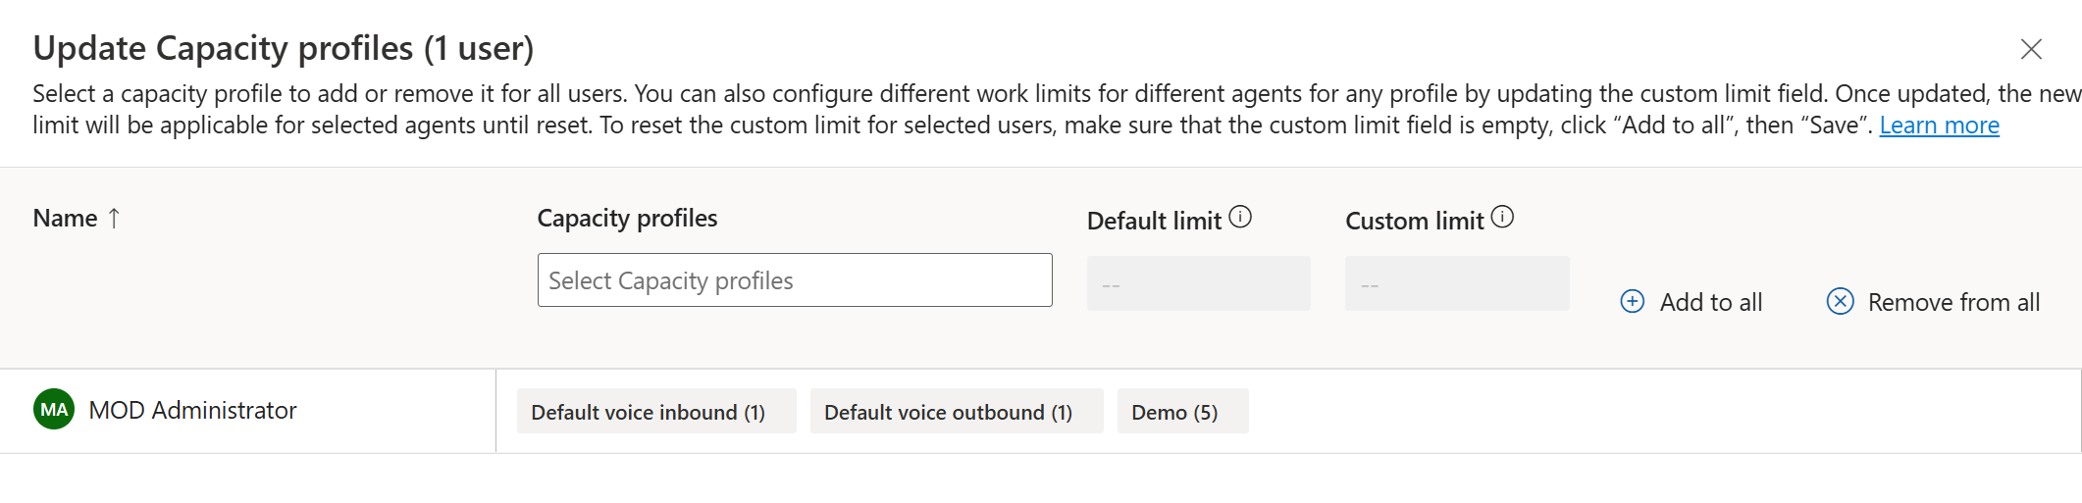
- Click on Close.

Conclusion
By completing this lab, you successfully activated the Dynamics 365 Contact Center trial, explored the Copilot Service workspace, and learned how to manage users and their attributes, including skills, queues, and capacity profiles. These steps are essential for setting up and managing a functional customer support environment within Dynamics 365 Copilot Service.

